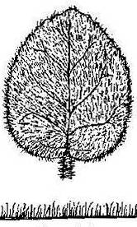
THE SCIENTIFIC METHOD

Names of Students in the Discussion Group

- OBERVATION: Leaves of some plants are covered by a dense layer of fine hairs.
- QUESTION: Why do some plants have pubescent or hairy leaves?
- HYPOTHESIS – What do you think?

Leaf drawing obtained on 8-28-07 from http://www.mv.helsinki.fi/jkolehma/kuvat/lehdet.jpg.

Come up with one “testable” hypothesis or several hypotheses to explain why some plants have hairy leaves.

Hypothesis #1

Hypothesis #2

Hypothesis #3

Hypothesis #4

Would you necessarily use the same Experiment to test the prediction based on the hypothesis you might choose to investigate?

If the data from you EXPERIMENT were consistent with the hypothesis that you tested would that “PROVE” that your hypothesis was true?

