Biology of the Cell - Practice Exam: Unit III (Answer key)

Multiple Choice: Choose the best answer. Be sure to look over all possible choices before making your selection.

1. Molecules with both hydrophilic and hydrophobic properties (such as sterols, phospholipids, and detergents) are termed ______________.

- amphipathic
- parapathic
- sympathetic
- psychopathic
- amphiparic

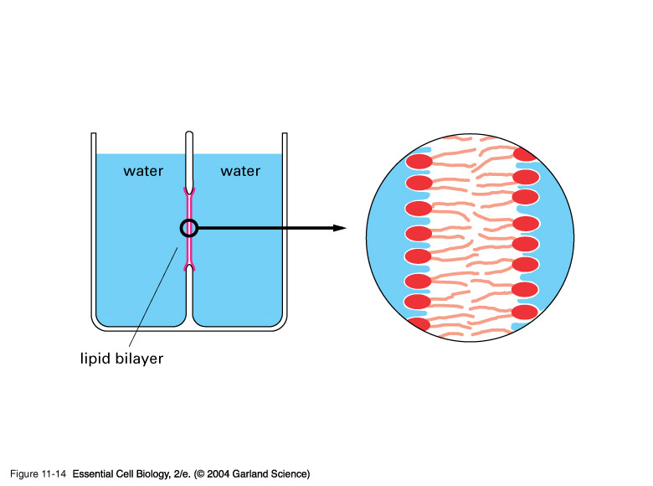
2. A hypothetical "microbullet" shot through a membranous phospholipid bilayer would pass the components in which order?

A. tail=======>tail=======>head=======>head
B. head=======>tail=======>head=======>tail
C. tail=======>head=======>head=======>tail
D. head=======>tail=======>tail=======>head
E. head=======>head=======>tail=======>tail

3. The phospholipid molecules of most membranes have a ___________________.

A. hydrophobic head and a single hydrophilic tail
B. hydrophobic head and a single hydrophobic tail
C. hydrophilic head and two hydrophobic tails
D. hydrophilic head and three hydrophobic tails
E. None of the above choices are correct.

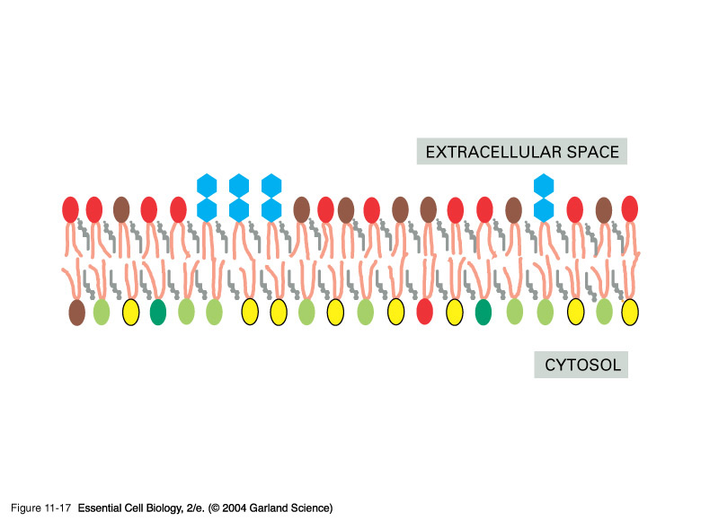
4. If the bilayer of the plasma or an internal cellular membrane were peeled apart, both sides of the membrane __________________________.
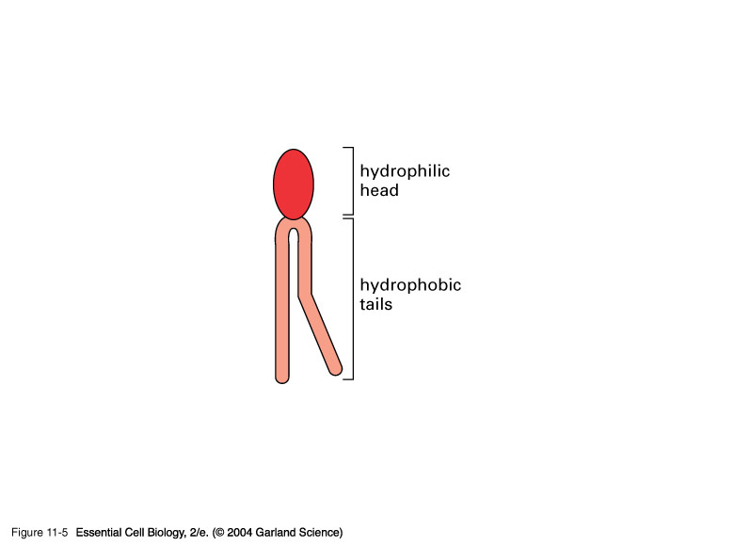
A. would be mirror images of each other
B. would not be mirror images of each other
C. would demonstrate symmetry
D. would begin synthesizing DNA
E. None of the above choices are correct.

5. Most membrane functions are carried out by ______________ associated with the lipid bilayer.

A. proteins
B. ribosomes
C. nucleic acids
- cellulose
- hormones

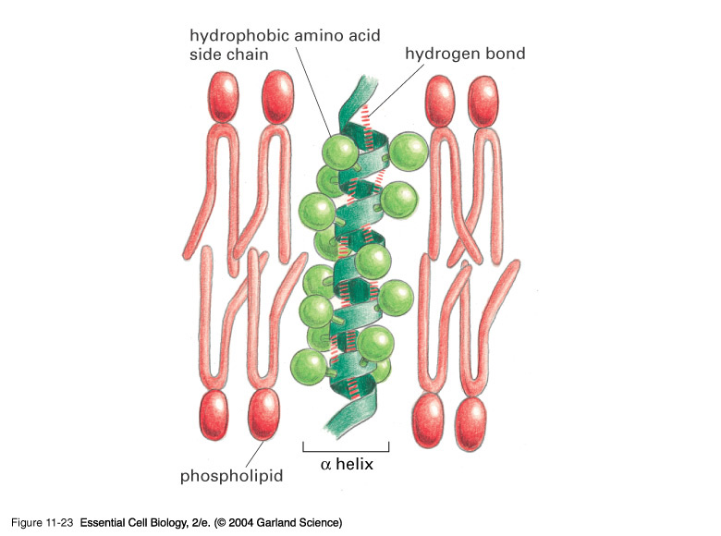
6. In a transmembrane or intregral protein, the portion that transverses the lipid bilayer with direct contact with the fatty acid tails of the phospholipids possesses ________________________.

- hydrophilic R groups or side chains
- hydrophobic R groups or side chains
- nonpolar peptide bonds
- ionic bonds extending from the central carbons of amino acids within the polypeptide chain
- sodium and potassium ions

7. Which of the following is NOT an example of a plasma membrane protein?

- receptors
- anchors
- transfusers
- enzymes
- transporters

8. Lateral diffusion, flexion, and rotation of proteins and lipids in a membrane are ______________ then a flip flop from one side of the phospholipid bilayer to the other.

- more likely to occur
- less likely to occur
- equally likely to occur
- probably improbable

9. Passive transport of water, oxygen, carbon dioxide, nitrogen, and benzene across the cell membrane ________________________.

A. can occur through the process of diffusion
B. can occur through the process of facilitated diffusion
C. requires no input of energy
D. All of the above choices are correct

10. Movement of a molecule against a concentration and/or electrical gradient is _________ and ______________.

A. simple diffusion; does not require the addition of energy
B. facilitated diffusion; requires the addition of energy
C. osmosis; does not require the addition of energy
D. active transport; requires the addition of energy
- bulk flow; does not require the addition of energy

11. If Solution A is hypertonic relative to Solution B, and Solution B is hypertonic relative to Solution C, then what is Solution C relative to Solution A?

A. hypotonic
B. isotonic
C. hypertonic

12. The Na⁺-K⁺ pump transports ions in a cyclic manner. The first thing that attaches to the transporter and begins the process from the cytosol side is ______________.

- sodium
- potassium
- phosphate from ATP
- potassium and sodium
- None of the above choices are correct.

13. If a human red blood cell is placed in a hypotonic solution, which will occur?

A. Solutes will move into the cell from the surrounding solution.
B. Water will move into the cell from the surrounding solution.
C. Solutes will move out of the cell into the surrounding solution.
D. Water will move out of the cell into the surrounding solution.
E. None of the above will occur.

14. Sugar and amino acids are carried into the cell by membrane proteins by means of __________________.

A. simple diffusion
B. facilitated diffusion
C. active transport
D. cotransport
E. Some of the above choices are correct.

15. The difference between osmotic pressure and physical pressure on either side of a selectively permeable membrane is called _____________________.

A. force of diffusion
B. water potential
C. workload
D. environmental resistance
E. carrying capacity

16. Anaerobic metabolism:

A. Converts huge quantities of food energy into ATP energy
B. Occurs in the cytosol
C. Requires oxygen
D. Captures light energy

17. When fats are used as fuel, the glycerol portion of the molecule enters the glycolytic pathway when converted to ___________________________.

A. fructose 1,6-bisphosphate
B. phosphoenolpyruvate
C. coenzyme A
D. acetyl CoA
E. pyruvate

18. Certain kinds of carbon compounds have a carboxylic acid group (COOH) held in such a manner that it can split off from the rest of the molecule. This process is called _______________.

A. decarboxylation
B. oxidation
C. phosphorylation
D. reduction
E. dephosphorylation

19. What is the significance of the conversion of pyruvic acid to lactic acid during anaerobic respiration?

A. Pyruvic acid becomes available to enter matrix reactions.
B. The citric acid cycle is initiated.
C. NAD+ is regenerated for use in glycolysis.
D. The oxidation of pyruvic acid becomes possible.

20. The first step in the activation of glucose for respiration is ______________________.

A. removal of a molecule of water
B. addition of a carboxyl group
C. removal of an atom of oxygen
D. addition of a phosphate group
E. addition of an atom of oxygen

21. The metabolic breakdown of one molecule of glucose harvests the greatest amount of useable energy during:

A. Glycolysis
B. Kreb’s cycle
C. Citric Acid cycle
D. Electron Transport
E. Fermentation

22. The final product of the electron transport chain in cellular respiration is a molecule of

A. water
B. ATP
C. Coenzyme A
D. Cytochrome
E. NADH

23. This process uses NADH and FADH₂ to produce ATP _________.

A. oxidative phosphorylation
B. fermentation
C. glycolysis

24. This process begins with the production of acetyl CoA:

A. chemiosmosis
B. glycolysis
C. fermentation
D. Kreb’s cycle
25. Muscle cramps during exercise are caused by ________________.

A. alcohol fermentation
B. glycolysis inhibition
C. lactic acid fermentation
D. chemiosmosis
E. an overdose of anabolic steroids

26. The chloroplast stroma _________________________.

A. is the watery matrix inside the grana
B. is the site of carbon dioxide fixation into sugars
C. is a cytoskeleton-like matrix in the cytoplasm
D. contains the reaction center
E. contains free floating chlorophyll

27. During the light-dependent reactions of photosynthesis in most plants (e.g., algae, ferns, mosses, flowering plants, etc.) _______________________.

A. carbon dioxide is combined with certain organic compounds in the plant, producing glucose
B. water molecules are split, through the energy of light, into hydrogen ions, electrons, and oxygen
C. water molecules are split, through the energy of light, into hydrogen and water
D. the hydrogen removed from water molecules is combined with carbon dioxide, forming glucose
E. None of the above are correct.

28. The photochemical (light-dependent) reactions of photosynthesis ____________.

A. occur in the thylakoid membranes of the grana.
B. require the presence of ATP, NADPH, and CO₂.
C. release oxygen from carbon dioxide.
D. occur at a faster rate in dim light than in bright light.
E. None of the above choices are correct.

29. When carbon dioxide is fixed to ribulose bisphosphate __________________________.

A. a stable six-carbon sugar. such as glucose is immediately produced.
B. the Calvin Cycle conversion of carbon dioxide into sugar is completed.
C. the unstable six-carbon intermediate breaks down into two 3 carbon atom containing molecules (i.e., 3-phosphoglycerate or PGA..
D. an oxygen molecule is released.
E. the light dependent (photochemical) reactions are initiated.

30. ATP and NADPH produced in the light dependent or photochemical reactions of photosynthesis are used in the Calvin Cycle to __________________________.

A. further breakdown glucose.
B. convert PGA to carbon dioxide.
C. produce glucose from carbon dioxide.
D. move sugars from the grana into the stroma of the chloroplast.
E. activate the mitochondria to perform cellular respiration.

