Spectrophotometry and its Applications in Microbiology

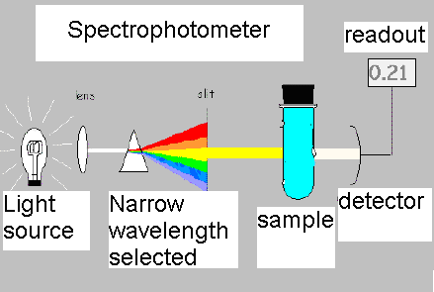
Certain covalent bonds in molecules are able to absorb energy at particular wavelengths ranging from infrared to ultraviolet. This absorbance is readily detected by using some kind of spectrometer which sends light of a specific wavelength through the sample; if the chemical absorbs energy, then the light arriving at the detector is less intense than the incident light that was shown on the sample. For most biological applications, the substance is in solution, the wavelength is that of visible light (350-700 nm) and the instrument used is a spectrophotometer.
Frequently, these measurements are made to determine the quantity of some chemical because fortunately, Beer’s Law states that the amount of light absorbed is proportional to the amount of the substance doing the absorbance, in other words:
A = lc where
A is the absorbance
 is the extinction or molar absorptivity coefficient, a characteristic of the molecule being measured which tells how much light is absorbed per mol of molecules
l is the pathlength, or the distance the light travels though the sample; a sample is placed into a cuvette which are designed to have a path length of 1 cm, conveniently
c is the concentration.
Thus, A, the absorbance, is directly proportional to c, the concentration.

Sometimes it is convenient to consider the flip side, that is, how much of the light makes it through to the detector instead of how much is absorbed. This is called Percent Transmittance which is defined mathematically as %T = 100 x I_{t} / I₀ where I_{t} is the light transmitted through the sample and reaches the detector and I₀ is the incident light.
The mathematical relationship between Absorbance and Percent Transmittance is:
A = 2 - log (%T)

It should be apparent from this discussion that the more of some substance there is, the more light will be absorbed (higher Absorbance reading) and the less light will pass through the sample to the detector (lower Percent Transmittance reading). Any spectrophotometer can be set so that the output is either A or %T. Also, it should be noted that in both cases the number obtained from measurements is unitless (“absorbance units”); both are derived from a ratio between the incident light and the transmitted light, so the units cancel.

While the analysis of biochemicals is important in microbiology, many times we are interested in using spectrophotometry as an easy way to determine the relative numbers of bacteria in a sample. This creates complications because Beer’s Law applies to molecules in solution, whereas bacteria are particles in suspension. Fortunately, Beer’s Law has been shown to apply in this case (known as the Beer-Lambert Law). Both %T and A are frequently used. I prefer to use A because then there is a direct relationship between the absorbance units and the number of bacteria, so it is intuitively more comfortable. I should note that the Biolog procedure for identifying bacteria that we may use later in the semester requires standardizing the number of bacteria in a sample using an instrument that has an output only in %T.
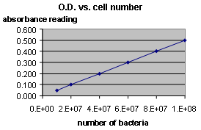
Although the relationship between the number of cells and the absorbance reading is still maintained, absorbance refers to the absorbance of light by molecules. This is NOT what we observe when placing a bacterial sample in a spectrophotometer. Light that doesn’t reach the detector has not been absorbed but rather scattered. Light scattering occurs when a suspension of particles is cloudy or “turbid”. Thus we are measuring the turbidity of the sample (some instruments used for this purpose are called turbidimeters). Since the reading we obtain when using the “absorbance” setting on the spectrophotometer is not truly absorbance, another term we use to describe this value is Optical Density or O.D.
In the Lysozyme Experiment, we will use turbidity measurements to observe damage to the cells caused by lysozyme. The O.D. reading we get from a sample of bacteria depends on the mass of the bacteria. As the bacteria break open due to the effects of the lysozyme, the cytoplasm will leak out. Because the proteins, salts, and small molecules that make up the cytoplasm of a cell are soluble, they will not contribute to the light scattering of the sample. Thus damage to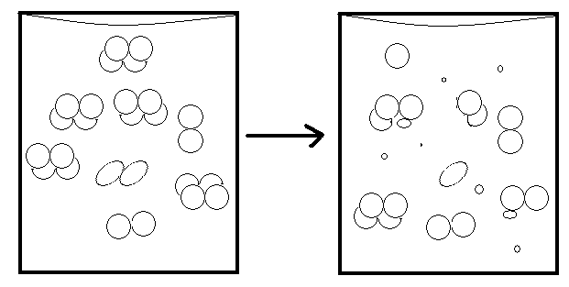 the cells will result in a decrease in Optical Density of the sample. Pieces of cells that reform after exploding open will be smaller in size and will therefore also scatter less light, producing a lower O.D. reading.

In this experiment, the wavelength of light used is not that important because we are looking at light scattering instead of the absorption of a narrow spectrum of light energy by a molecule. Your instructors will set the spectrophotometer to the Absorbance setting at a particular wavelength and then “blank” the instrument. A cuvette containing a clear liquid, such as your bacteria will be suspended in, will be placed into the instrument and the instrument electronically set for 0 Absorbance (no cells, no light scattered). When you take readings, they will be in “OD units” in the range of 0 to 1.0. Most spectrophotometers, for both theoretical and technical reasons, lose accuracy when samples produce readings much above 1.0 units.

