pGLO Transformation

Lesson 1 – Introduction to Transformation
In this lab you will perform a procedure known as a genetic transformation. Remember that a gene is a piece of DNA that provides the instructions for making (coding for) a protein which gives an organism a particular trait. Genetic transformation literally means change caused by genes and it involves the insertion of a gene(s) into an organism in order to change the organism’s trait(s). Genetic transformation is used in many areas of biotechnology. In agriculture, genes coding for traits such as frost, pest, or spoilage resistance can be genetically transformed into plants. In bio-remediation, bacteria can be genetically transformed with genes enabling them to digest oil spills. In medicine, diseases caused by defective genes are beginning to be treated by gene therapy; that is, by genetically transforming a sick person’s cells with healthy copies of the gene involved in their disease.
You will use a procedure to transform bacteria with a gene that codes for a Green Fluorescent Protein (GFP). The real-life source of this gene is the bioluminescent jellyfish Aequorea victoria. The gene codes for a Green Fluorescent Protein that causes the jellyfish to fluoresce and glow in the dark. Following the transformation procedure, the bacteria express their newly acquired jellyfish gene and produce the fluorescent protein that causes them to glow a brilliant green color under ultraviolet light.
In this activity, you will learn about the process of moving genes from one organism to another with the aid of a plasmid. In addition to one large chromosome, bacteria naturally contain one or more small circular pieces of DNA called plasmids. Plasmid DNA usually contains genes for one or more traits that may be beneficial to bacterial survival. In nature, bacteria can transfer plasmids back and forth allowing them to share these beneficial genes. This natural mechanism allows bacteria to adapt to new environments. The recent occurrence of bacterial resistance to antibiotics is due to the transmission of plasmids.
Bio-Rad’s unique pGLO plasmid encodes the gene for the Green Fluorescent Protein (GFP) and a gene for resistance to the antibiotic ampicillin. pGLO also incorporates a special gene regulation system which can be used to control expression of the fluorescent protein in transformed cells. The gene for the Green Fluorescent Protein can be switched on in transformed cells by adding the sugar, arabinose, to the cells nutrient medium. Selection for cells that have been transformed with pGLO DNA is accomplished by growth on antibiotic plates. Transformed cells will appear white (wild type phenotype) on plates not containing arabinose, and fluorescent green when arabinose is included in the nutrient agar.
You will be provided with the tools and a protocol for performing genetic transformation.
Your task will be:
1. To do the genetic transformation.
2. To determine the degree of success in your efforts to genetically alter an organism.

Lesson 1 Focus Questions
There are many considerations that need to be thought through in the process of planning a scientific laboratory investigation. Below are a few for you to ponder as you take on the challenge of doing a genetic transformation.
Since scientific laboratory investigations are designed to get information about a question, our first step might be to formulate a question for this investigation.
Consideration 1 – Can I genetically transform an organism? Which organism?
1. To genetically transform an entire organism, you must insert the new gene(s) into every cell in the organism. Which organism is better suited for total genetic transformation—one composed of many cells, or one composed of a single cell?
2. Scientists often want to know if the genetically transformed organism can pass its new traits on to its offspring and future generations. To get this information, which would be a better candidate for your investigation, an organism in which each new generation develops and reproduces quickly, or one that does this more slowly?
3. Based on the above considerations, which would be the best choice for a genetic transformation:
bacteria, earthworm, fish, or mouse?
Consideration 2 – How can I tell if cells have been genetically transformed?
Recall that the goal of genetic transformation is to change an organism’s traits (phenotype). Before any change in the phenotype of an organism can be detected, a thorough examination of its natural (pre-transformation) phenotype must be made. Look at the colonies of E. coli on your starter plates. List all observable traits or characteristics that can be described:
The following pre-transformation observations of E. coli might provide base-line data to make reference to when attempting to determine if any genetic transformation has occurred.
a) Number of colonies
b) Size of : 1) the largest colony
2) the smallest colony
3) the majority of colonies
c) Color of the colonies
d) Distribution of the colonies on the plate
e) Visible appearance when viewed with ultraviolet (UV) light
f) The ability of the cells to live and reproduce in the presence of an antibiotic such as ampicillin
Consideration 3 – The Genes
Genetic transformation involves the insertion of some new DNA into the E. coli cells. In addition to one large chromosome, bacteria often contain one or more small circular pieces of DNA called plasmids. Plasmid DNA usually contains genes for more than one trait. Scientists can use a process called genetic engineering to insert genes coding for new traits into a plasmid. In this case, the pGLO plasmid carries the gene (GFP) that produces the green fluorescent protein and a gene (bla) that codes for a protein that gives the bacteria resistance to an antibiotic. The genetically engineered plasmid can then be used to genetically transform bacteria to give them this new trait(s).
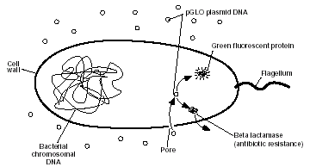
Consideration 4 – The Act of Transformation
This transformation procedure involves three main steps. These steps are intended to introduce the plasmid DNA into the E. coli cells and provide an environment for the cells to express their newly acquired genes.
To move the plasmid DNA - pGLO through the cell membrane you will:
1. Use a transformation solution of CaCl2 (calcium chloride)
2. Carry out a procedure referred to as heat shock
For transformed cells to grow in the presence of ampicillin you must:
3. Provide them with nutrients and a short incubation period to begin expressing their newly acquired genes

Glossary of Terms
Agar Provides a solid matrix to support bacterial growth. Contains nutrient mixture of carbohydrates, amino acids, nucleotides, salts, and vitamins.
Antibiotic Selection The plasmid used to move genes into bacteria also contains the gene for beta-lactamase that provides resistance to the antibiotic ampicillin. The beta-lactamase protein is produced and secreted by bacteria that contain the plasmid. The secreted beta-lactamase inactivates the ampicillin present in the LB/agar, which allows for bacterial growth. Only bacteria that contain the plasmids, and express beta-lactamase can survive on the plates that contain ampicillin. Only a very small percentage of the cells take up the plasmid DNA and are transformed. Non- transformed cells, cells that do not contain the plasmid, can not grow on the ampicillin selection plates.
Arabinose A carbohydrate, normally used as source of food by bacteria.
Beta-Lactamase Beta-lactamase is a protein that provides resistance to the antibiotic ampicillin. The beta-lactamase protein is produced and secreted by bacteria that have been transformed with a plasmid containing the gene for betalactamase. The secreted beta-lactamase inactivates the ampicillin present in the LB/agar, which allows for bacterial growth and expression of newly acquired genes also contained on the plasmid i.e. GFP.
Biotechnology Applying biology in the real world by the specific manipulation of living organisms, especially at the genetic level, to produce potentially beneficial products.
Cloning When a population of cells is prepared by growth from a single cell, all the cells in the population will be genetically identical. Such a population is called clonal. The process of creating a clonal population is called “cloning”. Identical copies of a specific DNA sequence, or gene, can be accomplished following mitotic division of a transformed host cell.
Colony A clump of genetically identical bacterial cells growing on an agar plate. Because all the cells in a single colony are genetically identical they are called clones.
Culture Media The liquid and solid media are referred to as LB (named after Luria-Bertani) broth and agar are made from an extract of yeast and an enzymatic digest of meat byproducts that provides a mixture of carbohydrates, amino acids, nucleotides, salts, and vitamins, all of which are nutrients for bacterial growth. Agar, which is from seaweed, polymerizes when heated to form a solid gel (very analogous to Jell-O), and functions to provide a solid support on which to culture the bacteria.
Genetic Engineering The manipulation of an organism’s genetic material (DNA) by introducing or eliminating specific genes.
Gene Regulation Gene expression in all organisms is carefully regulated to allow for differing conditions and to prevent wasteful overproduction of unneeded proteins. The genes involved in the transport and breakdown of food are good examples of highly regulated genes. For example, the simple sugar, arabinose, can be used as a source of energy and carbon by bacteria. The bacterial enzymes that are needed to breakdown or digest arabinose for food are not expressed in the absence of arabinose but are expressed when arabinose is present in the environment. In other words when arabinose is around the genes for these digestive enzymes are turned on. When arabinose runs out these genes are turned back off.
Green Fluorescent Protein Green Fluorescent Protein (GFP) was originally isolated from the bioluminescent jellyfish, Aequorea victoria. The gene for GFP has recently been cloned. The unique three-dimensional conformation of GFP causes it to resonate when exposed to ultraviolet and give off energy in the form of visible green light.
Plasmid A circular DNA molecule, capable of autonomous replication, carrying one or more genes for antibiotic resistance proteins and a cloned foreign gene such as GFP.
pGLO Plasmid containing the GFP sequence and ampicillin resistance gene which codes for Beta-lactamase.
Recombinant DNA Technology The process of cutting and recombining DNA fragments as a means to isolate genes or to alter their structure and function.
Screening Process of identifying wanted bacteria from a bacterial library.
Sterile Technique Minimizing the possibility of outside bacterial contamination during an experiment through observance of cleanliness and using careful laboratory techniques.
Streaking Process of passing an inoculating loop with bacteria on it across an agar plate
Vector An autonomously replicating DNA molecule into which foreign DNA fragments are inserted and then propagated in a host cell (i.e. plasmid).

Transformation Procedure
1. Label one closed micro test tube +DNA and another -DNA. Label both tubes with your group’s name. Place them in the foam tube rack.
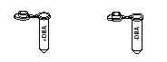
2. Open the tubes and, using a sterile transfer pipette, transfer 250 µl of Transformation Solution (CaCl2) into each tube.

3. Place the tubes on ice.

4. Use a sterile loop to pick up one single colony of bacteria from your starter plate. Pick up the +DNA tube and immerse the loop into the Transformation Solution at the bottom of the tube. Spin the loop between your index finger and thumb until the entire colony is dispersed in the Transformation Solution (no floating chunks). Place the tube back in the tube rack in the ice. Using a new sterile loop, repeat for the -DNA tube.

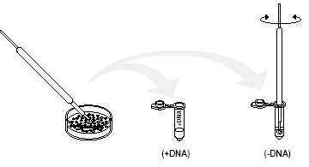
5. Examine the pGLO DNA solution with the UV lamp. Note your observations. Immerse a new sterile loop into the plasmid DNA stock tube. Withdraw a loop full. There should be a film of plasmid solution across the ring. This is similar to seeing a soapy film across a ring for blowing soap bubbles. Mix the loop full into the cell suspension of the +DNA tube. Close the tube and return it to the rack on ice. Also close the -DNA tube. Do not add plasmid DNA to the -DNA tube. Why not?

6. Incubate the tubes on ice for 10 minutes. Make sure to push the tubes all the way down in the rack so the bottom of the tubes stick out and make contact with the ice.

7. While the tubes are sitting on ice, label your four agar plates on the bottom (not the lid) as follows:
• Label one LB/amp plate: + DNA
• Label the LB/amp/ara plate: + DNA
• Label the other LB/amp plate: - DNA
• Label the LB plate: - DNA
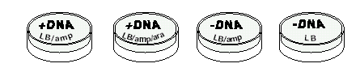
8. Heat shock. Using the foam rack as a holder, transfer both the (+) and (-) tubes into the water bath set at 42° C for exactly 50 seconds. Make sure to push the tubes all the way down in the rack so the bottom of the tubes stick out and make contact with the warm water. When the 50 seconds are done, place both tubes back on ice. For the best transformation results, the change from the ice (0°C) to 42°C and then back to the ice must be rapid. Incubate tubes on ice for 2 minutes.

9. Remove the rack containing the tubes from the ice and place on the bench top. Open a tube and, using a new sterile pipette, add 250 µl of LB broth to the tube and re-close it. Repeat with a new sterile pipette for the other tube. Incubate the tubes for 10 minutes at room temperature.

10. Tap the closed tubes with your finger to mix. Using a new sterile pipette for each tube, pipette 100 µl of the transformation and control suspensions onto the appropriate plates.
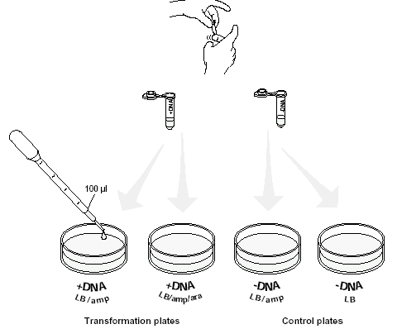
11. Use a new sterile loop for each plate. Spread the suspensions evenly around the surface of the agar by quickly skating the flat surface of a new sterile loop back and forth across the plate surface.
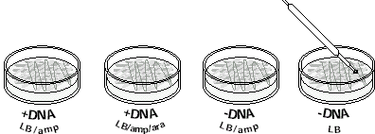
12. Stack up your plates and tape them together. Put your group name and class period on the bottom of the stack and place it upside down in the 37°C incubator until the next day.
